Rachid Azrout,

Faculty of Social and Behavioural Sciences

Course: Content Analysis

Content Analysis: Codebook

**Andjela Mestrovic**

12334707

[12334707@uva.nl](mailto:11348801@uva.nl)

**Inga Vondenhof**

12052825

[12052825@uva.nl](mailto:11348801@uva.nl)

**Yuhui Chen**

14172372

[14172372@uva.nl](mailto:11348801@uva.nl)

**Helge Moes**

11348801

[11348801@uva.nl](mailto:11348801@uva.nl)

Date: 17.02.2023

Word count: 1768

**Table of Content**

**Research Problem 3**

**Key Concepts 3**

Reddit 3

Humor type 4

**Research Question 4**

Sub Questions 4

**Description of Units 5**

**General Instruction 5**

Step 1 - Go to a random post 5

Step 2 - Get the first “top” and “controversial” comment 6

Step 3 - Access both comments to code 7

Step 4 - Expand the first and select the right comment 8

Figure 7a. An example of the first comment not being shown instantly. 8

An overview of variables 8

Administration 9

Part A: Context 9

Part B: Coding humor 9

**References 20**

**Appendices 21**

Appendix A - Python script for random post-URL generation on subreddits. 21

Appendix B - Example of randomly generated reddit URLs (10 for each subreddit) 22

# 

# **Research Problem**

People form opinions based on the information they consume on social media. As a result, it is crucial to understand what type of content attracts people’s attention on social media and drives discussions. Whereas, characteristics such as humor in general have persuasive power. Limited research has shown that humorous contents are able to grab more attention (Schmidt, [1994](https://link.springer.com/article/10.1007/s11109-008-9064-y#ref-CR48)), increase the likeability of the source (Sternthall & Samuel, 1973), and promote a pleasant mood for people to be more agreeable (Sinclair et al., [1994](https://link.springer.com/article/10.1007/s11109-008-9064-y#ref-CR49)).

Humor is an important aspect of many subreddits, as it can enhance user engagement and contribute to the overall atmosphere of a community. When used appropriately, humor can be a tool for building social connections and fostering a sense of community among subreddit users. Researching the role of humor in subreddits is important for a few reasons. Firstly, it can provide insights into how users interact with each other in online communities and the role that humor plays in shaping those interactions. Secondly, it can help moderators and community managers better understand how to create a positive and engaging atmosphere within their subreddits.

In this content analysis, we focus on online discussions that take place on Reddit. Reddit is an American platform that is known for its news aggregation, content rating, and discussions. The topics discussed on Reddit are so different that there are various subreddits to specify certain topics users talk about within the community. In this research, three of the most active subreddits: r/Gaming, r/AskReddit, and r/funny are used as the source of the content, where the content of r/AskReddit tends to be more objective and formal discussion, while the discussion of the r/funny is more subjective and casual, the r/Gaming can be seen as a mix of the two.

The findings of such a research may be applicable to other similar platforms, although the generalizability may vary depending on the specific characteristics of the platform in question. For instance, the ways in which humor is used on Twitter or Facebook may differ from how it is used on Reddit, due to differences in the structure and culture of these platforms. However, by studying how humor operates on one platform, researchers can develop hypotheses about how it might operate on other platforms and test those hypotheses in future studies. We aim to investigate what role humor plays in the content that gets the greatest attention in each of the three most popular subreddits. How do the first comments below a post differ, from the most upvoted (most liked) comment to those that are most controversial, as well as from community to community?

# **Key Concepts**

## **Reddit**

Reddit is an American social news website. Advance Magazine Publishers Inc. holds a majority stake in it (Anderson, 2015). Reddit allows users (also known as Redditors) to add their own posts in the form of a link, a photo, or a video or their own text and to respond to these posts. In doing so, it is possible to remain completely anonymous, since account names can be randomly generated. Upvote and downvote buttons allow users to judge posts and responses to increase or decrease their visibility. They also have the ability to subscribe to individual categories, and subreddits created around specific interests and topics (Anderson, 2015). Comments on specific posts can be categorized into ‘Best’, ‘Top’, ‘New’, ‘Controversial’, ‘Old’ and ‘Q&A’. In this content analysis we focus on ‘Top’ and ‘Controversial’ comments, which are the first comments that show at the top of the comment page when sorting the comment section and the comments that are sorted by controversial.

## **Humor type**

Humor type is a concept that has not been elaborately researched within media entertainment. This is due to the challenge of demarcating a specific characteristic of humor. van der Wal et al. (2020) conducted research in an attempt to characterize these humor types. These are based on three theories: relief, superiority, and incongruity theory.

Relief theory concerns the humor that releases tension (or arousal), an example of such is irreverent humor (van der Wal et al., 2020).

Superiority theory describes the manner aggression is implemented as a component of humor. The enjoyment emerges from the sense of superiority one experiences when comparing themselves to others’ misfortunes (van der Wal et al., 2020).

Finally, incongruity theory emphasizes the cognitive processes that lead to the perception of humor (van der Wal et al., 2020). The appreciation of humor depends on the individual’s cognitive development.

# **Research Question**

*RQ:* What is the difference in expressing humor between ‘Top’ and ‘Controversial’ comments in three different Subreddits?

## **Sub Questions**

Below is a list of sub-questions that relate to the overall research question.

Type of subreddit: r/funny, r/AskReddit, r/Gaming

* How do these three Subreddits compare in the type of humor employed by users in the comments?

Type of comment: top, controversial

* Do controversial comments include humoristic elements?
* Which type of humor is most prevalent in controversial comments?
* Does the type of humor in controversial comments differ from top-comments?
  + Definition “Top” Comment: A “top” comment on Reddit is the first comment that shows at the top of the comment page (below the post) when sorting the comment section by “top”.
  + Definition “Controversial” Comment: A “controversial” comment on Reddit is the first comment that shows at the top of the comment page (below the post) when sorting the comment section by “controversial”.

Presence of humor:

* How many of the “top” and “controversial” comments include humor?

Type of humor:

* What type of humor is employed in the different comments or subreddits?

# **Description of Units**

Registration unit: The content of two user-written comments appears first under the sorting categories “Top” and “Controversial”.

Context unit: The subreddit, the original post.

# **General Instruction**

Below is a step-by-step instruction on how to access the comments which need to be coded.

## **Step 1 - Go to a random post**

A python script was used to randomly sample eighty URLs from each subreddit (r/funny, r/Gaming, r/AskReddit) out of a selection pool of 100.000 posts from the category “Top”, sorted by “last year” (February 2022- February 2023), see Appendix A. These URLs are printed in a .txt file, from which the link can be directed to a top or controversial post.

**Figure 1.** Example text file containing 80 links to random posts from r/funny.

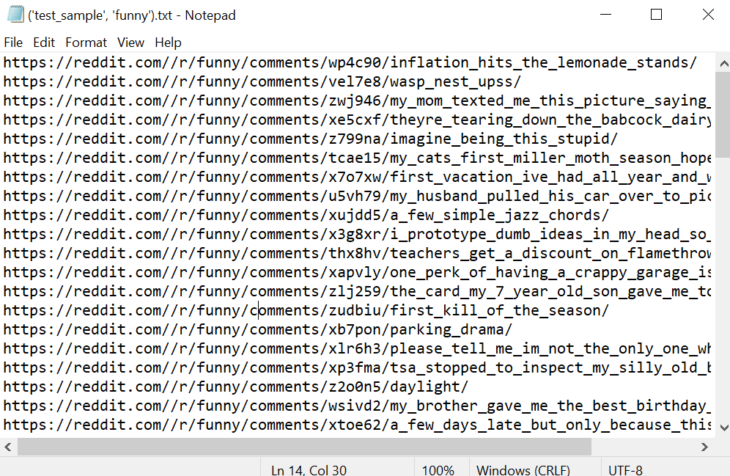

**Figure 2.** The sorting of r/funny from which the posts are sampled by the Python script (<https://www.reddit.com/r/funny/top/?t=year>)

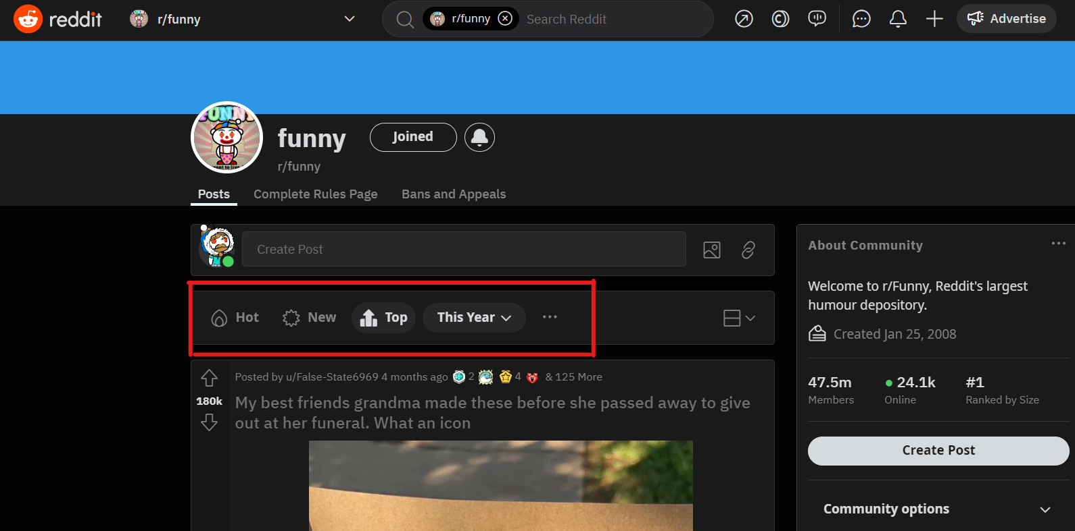

Three test lists of eighty URLs (one for each subreddit) were created for piloting, which are posted in Appendix B for preview. For the actual coding, every researcher gets one randomized text file for each subreddit, containing as many links as they need.

**Figure 3.** A screenshot of the post of the first link ([click here](https://reddit.com//r/funny/comments/wp4c90/inflation_hits_the_lemonade_stands/)).

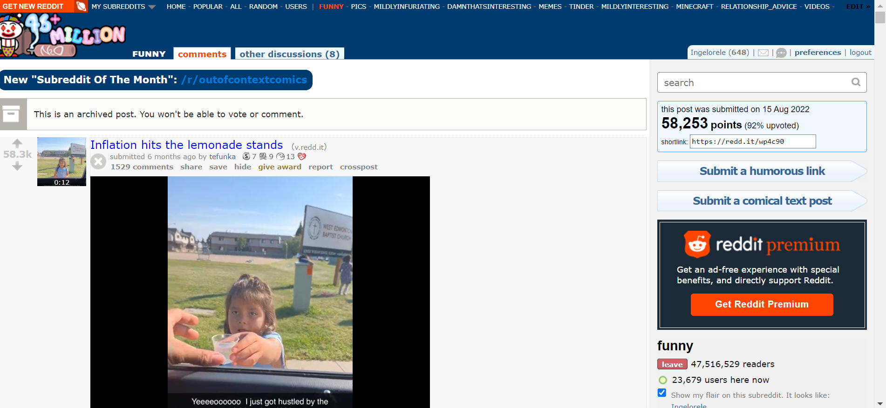

## **Step 2 - Get the first “top” and “controversial” comment**

Scroll down and get to the comment section. **Only code the very first comment which was made by a user. If a moderator or the author themselves deleted the comment, code the next comment. Do not code any replies**.There is a drop-down menu, which is “sorted by: best” by default. Click on it and select 1) top and open 2) controversial in a new tab or when done with coding 1).

**Note**: Once you sort the comments, the website changes its look from ‘old Reddit to ‘new Reddit. Nothing else is changed, the post and content remains the same.

**Figure 4.** The comment sorting box with both categories.

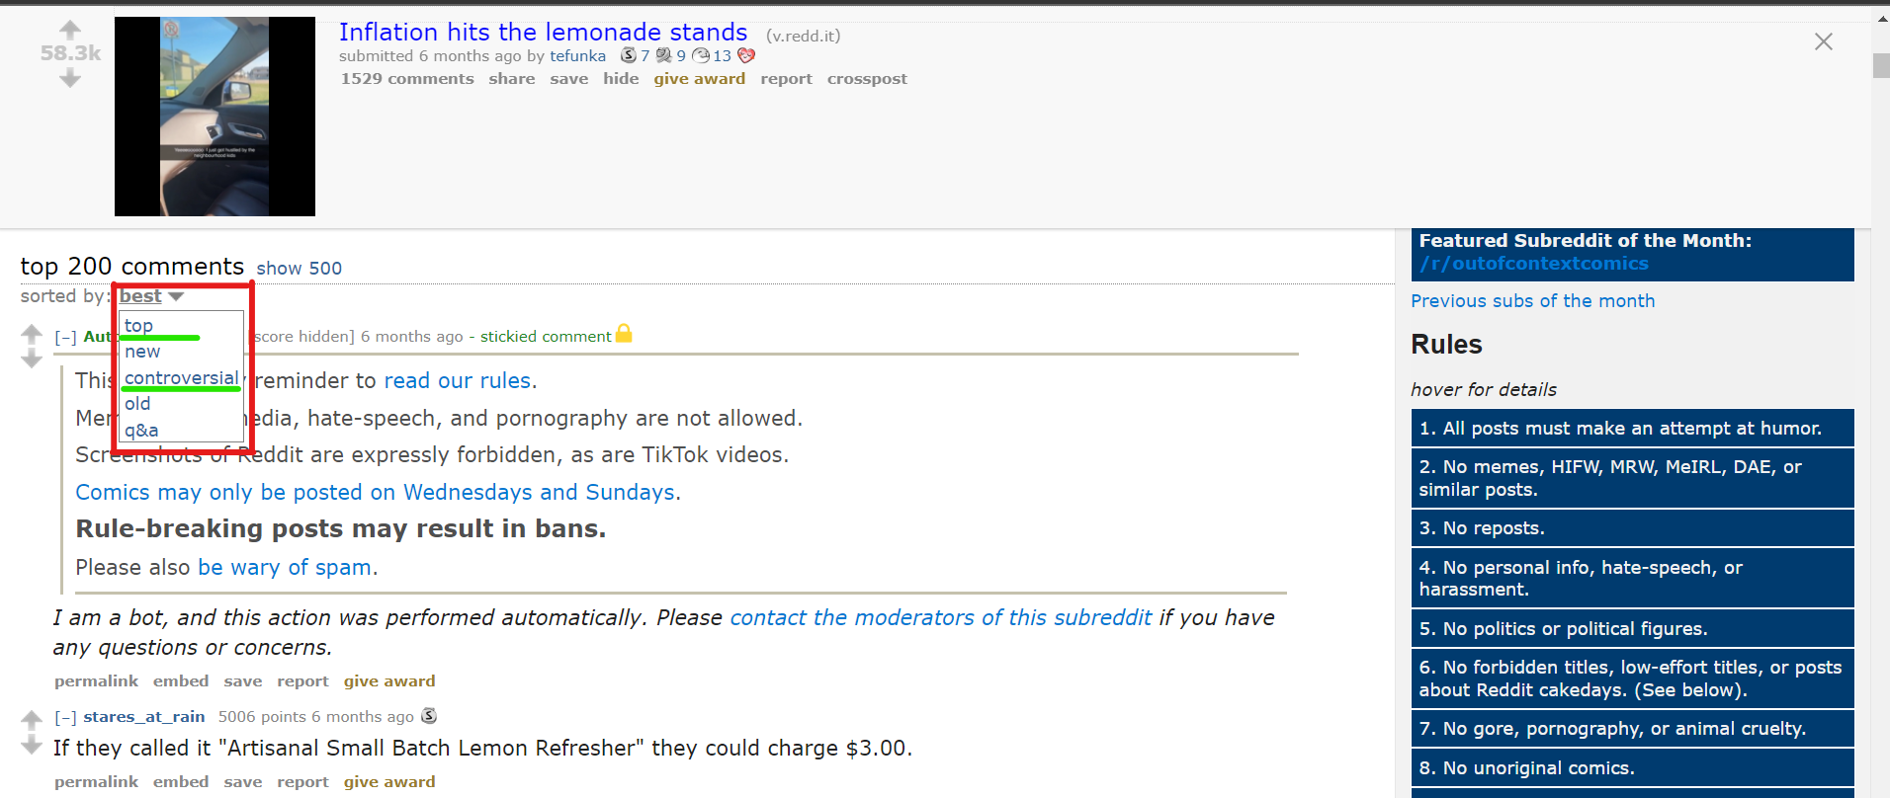

## **Step 3 - Access both comments to code**

Scroll past any comment posted by a “stickied comment” (usually posted by mods or bots) to see the first user-generated comment. Now, you can start coding.

**Figure 5.** The first comment to show when selecting “Sort By: Top”.

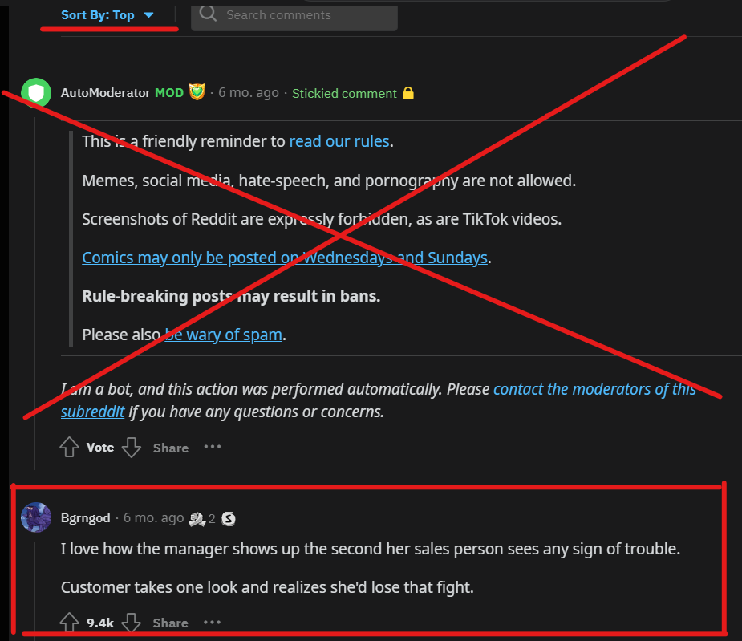

**Figure 6.** The first comment to show when selecting “Sort By: Controversial”.

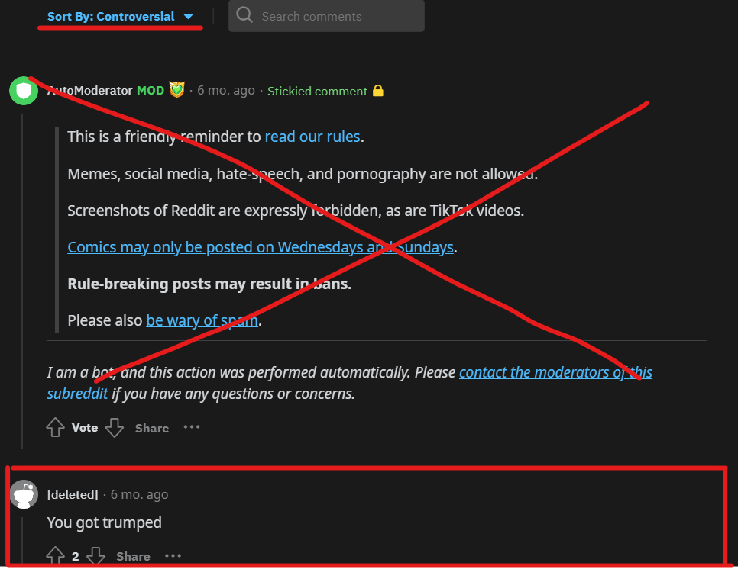

## **Step 4 - Expand the first and select the right comment**

In some instances, comments on reddit need to be expanded first before showing the content. If that is the case for the first comment, please press on the two little blue arrows just in front of the user name to expand the comment (see Figure 7a and 7b).

## **Figure 7a.** An example of the first comment not being shown instantly.

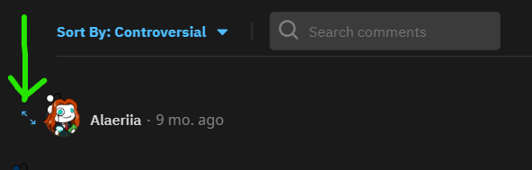

**Figure 7b.** The same comment, now expanded.

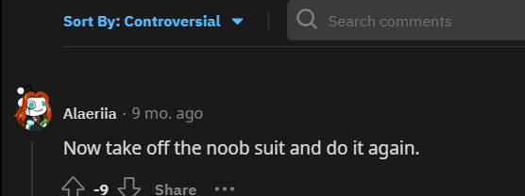

**Figure 8.** The aforementioned steps are automated through Python into an excel file containing the links of “top” and “controversial comments” to direct the coder.

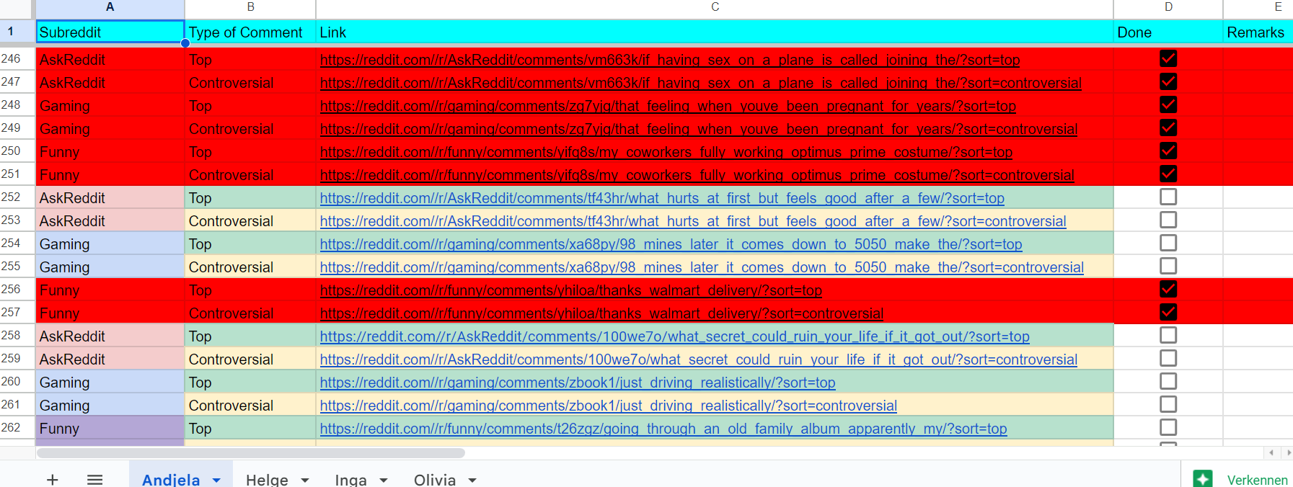

## **An overview of variables**

**Administration**

A1. Coder

**Context**

C1.subreddits

C2. Links

C3. Type of the comment

**Coding Humor**

H1. Aggressive Humor

H2. Self-defeating Humor

H3. Sexual Humor

H4. Irreverent Humor

H5. Coping Humor

H6. Parody Humor

H7. Wordplay Humor

H8. Incongruity Humor

H9. Absurdity Humor

H10. Hyperbole Humor

H11. Absence of Humor

H12. Additional remarks

## **Administration**

**A1. Who is the coder? (X)**

1= Andjela

2 = Yuhui

3 = Helge

4 = Inga

## **Part A: Context**

**C1. What is the subreddit?**

Please indicate from which subreddit the post you sampled is.

1. r/funny (F)
2. r/AskReddit (A)
3. r/gaming (G)

**C2. What is the link to the post? (F_P1, A_P1, G_P1)**

Please copy-paste the direct URL of the post you sampled here.

Open text box: *Insert the link here*

**C3. What type is the comment?**

Please indicate whether you are coding the top or controversial comment.

1. sort by “top” (T)
2. sort by “controversial” (C)

## **Part B: Coding humor**

**General definition of humor:** (Meriam-Webster)**:** “**a.** funny or amusing quality, **b.** the ability to be funny, **c.** a sudden, unpredictable, or unreasoning inclination”

Please read the definitions and examples of the humor type in the table below to start coding the comment, adapted from van der Wal, Piotrowski, Fikkers, & Valkenburg (2020).

**Figure 6.** Table of humor types with definitions.

| **Humor Type** | **Definition** | **Examples from Reddit comments** |
| --- | --- | --- |
| **Aggressive** | To ridicule or make fun at the expense of someone | “Home boi built like the mfs from WALL-E”  A post of a Chinese Mcdonald's shows has bicycle chairs: “this is what these fat ass 600lbs American whales need” |
| **Self-defeating** | Poking fun at one’s own faults | The original post contains the question: “What is that one thing you wished you are good at?”. A user responded:  “Making good decisions in life” |
| **Sexual** | Involves referring to sexual or risqué content | “So which side are my nuts supposed to hang from, or can I alternate? Also, how deep in my buttcrack are they supposed to go?” |
| **Irreverent** | Lack of respect for authority, which includes taboo, poor in taste or vulgar humor | “I live in Turkey. At this point I'd enthusiastically vote for a lamppost as long as it ran against Erdoğan.”, “What does America do best? -"Thoughts and prayers" by which I mean "doing nothing when action is urgently needed.” |
| **Coping** | Involves misfortune (“an unfortunate condition or event”), for example death, (mental) illness, accidents, etc. as a coping mechanism for daily life situations | “Tip from the Pros. Be a fat, unhealthy bastard and you'll never have to worry about Organ Harvesting. You'll also never have to worry about being invited to a threesome” |
| **Parody** | Making fun at known situations, public figures and things | Post about Chaplin as Mexican ambassador in Qatar wearing red clothes: “Is that a bright color on his clothes? I hope he's doing ok” |
| **Wordplay** | Play on words in the form of puns or misinterpretation | “HOME is where HO and ME come together”,  “Bjorns of Reddit, how do you keep from saying “Good Bjorning” when greeting friends or co-workers in the morning?” |
| **Incongruity** | Involves an unexpected outcome or that what takes someone by surprise | “One of my ‘favorites was a Dark Souls review, “I hate this game. I keep dying. 10/10.” |
| **Absurdity** | Things or behavior that is based on nonsense or illogical rules (stupid humor) | “If I wrote a letter every time I farted, id still be writing letters” |
| **Hyperbole** | Exaggerates ideas beyond their literal meaning for the sake of emphasis. | The post shows a video of someone pranking their cat with a finger on their body to show that it ‘got something there’ whereafter the person pulls their finger up to their nose, so the cat almost falls back. The cat is stunned with an angry face. The comment reads: “The owner of the hand is in extreme danger, would recommend not sleeping tonight” |

**Tips:**

Consider the context and tone of the comment when deciding whether it should be coded as humor. Some content may be sarcastic, ironic, or may include some elements of the definitions above, but not intended to be humorous.

Also, you may consider the context of the post when making your evaluation of the comment, as it may be a humorous response directly referring to the original post.

If the comment contains more than one type of humor, please remember that the categories are not meant to be mutually exclusive. One comment can exhibit more than one type of humor.

Based on van der Wal (2020), a coder may not perceive something as humorous. Therefore, the coder must still recognize that an incident is *meant to be* humorous by the person in question or the creators of the show and thus code it as humorous content. Furthermore, the humor that may be encountered can be experienced as difficult to interpret. Consequently, the coder is to be careful to be biased at their own sense of humor with regard to examining the comment.

**Sarcasm & Cynicism:**

If you see the comment includes sarcasm or cynicism, please re-evaluate whether there is actual humorous intent. If you are unsure whether to code it as humor or not, do not code the comment as humorous.

**HP1a: Please copy-paste the content of the comment here. Make sure to include the whole text:**

*Open text box*

**HP1b: Does the comment include humor?**

1. yes
2. no

**H1. Aggressive Humor**

**Definition “Aggressive Humor” :** To ridicule or make fun at the expense of someone. It relates to the tendency to express humor without regard for its potential impact on others (e.g., sexist or racist humor), and includes compulsive expressions of humor in which one finds it difficult to resist the impulse to say funny things that are likely to hurt or alienate others. This can also be done in a friendly manner (“clever humor”/”poking fun at someone”) but it is still at the expense of that person and can be hurtful for that person. All instances of humor that are at the expense of someone else/have a clear victim should be coded as aggressive humor.

Notes v. d. Wal (2020):

– Sometimes it is hard to make a distinction between serious aggression and aggressive humor. When the aggression is portrayed in a serious fashion, yet, you feel that it is *meant to be* funny by the author of the comment, code it as aggressive humor. When the aggression appears to be just aggressive, not with a humorous undertone, you should refrain from coding this instance as humor.

Sometimes, you may think because the comment includes an insult, and in relation to the post it appears funny. When that happens, re-think: Does the comment include humor in itself, and a punchline? If not, it needs to be coded “no”, as it is just a pure insult.

***Examples:***

* “Home boi built like the mfs from WALL-E”
* A post of a Chinese Mcdonald's shows has bicycle chairs: “this is what these fat ass 600lbs American whales need”

**H1a. Does the comment have an instance of humor directed towards a clear victim (criticizes or puts someone down)?**

1. Yes (1)
2. No (0)

**H2. Self-defeating Humor**

**Definition “Self-defeating Humor”:**Poking fun at one’s own faults. It involves excessively self-disparaging humor and attempts to amuse others by doing or saying funny things at one’s own expense to ingratiate oneself or gain approval, allowing oneself to be the “butt” of others’ humor.

Note v. d. Wal (2020):

– In order to code something as self-defeating someone has to be making fun of/jokes about themselves. Someone acknowledging their own faults is not enough. Someone has to *poke fun* at his/her faults.

***Example:***

* The original post contains the question: “What is that one thing you wished you are good at?”. A user responded: “Making good decisions in life”

**H2a. Does the comment poke fun at the comments’ author’s faults or shortcomings?**

1. Yes (1)
2. No (0)

**H3. Sexual Humor**

**Definition “Sexual Humor”:** involves alluding to, hinting at, or making a reference or insinuation to sexual or “naughty” matters (v.d. Wal, 2020).

***Examples:***

* “So which side are my nuts supposed to hang from, or can I alternate? Also, how deep in my buttcrack are they supposed to go?”
* In a post of a sign with “man inside” and a human figure: Graphic is unclear. Please draw a dick on it.

**H3a. Is the comment directly referring to sexual content?**

1. Yes (1)
2. No (0)

**H3b. Is the comment sexually suggestive?**

1. Yes (1)
2. No (0)

**H4. Irreverent Humor**

**Definition “Irreverent Humor”:** Lack of respect for authority, which includes taboo, poor in taste or vulgar humor

Note v.d. Wal:

* Bathroom humor (e.g., humor about farting, wetting/shitting oneself, etcetera)
* Humor that contains excessive swearing or profanity
* Sinister/cruel humor about sickness, death, or violence

***Example:***

* “I live in Turkey. At this point I'd enthusiastically vote for a lamppost as long as it ran against Erdoğan.”
* “What does America do best? -"Thoughts and prayers" by which I mean "doing nothing when action is urgently needed.”
* In a post of a disabled female without legs doing pushing ups: "Does she leave a wet trail like a snail?"

**H4a. Does the comment include a lack of respect for authority?**

1. Yes (1)
2. No (0)

**H4b. Does the comment include something rude and is likely to upset or anger people?**

1. Yes (1)
2. No (0)

**H4c. Does the comment reference something offensive (i.e. not “politically correct”)?**

1. Yes (1)
2. No (0)

**H4d. Does the comment refer to sex and/or the human body in an unpleasant way?**

1. Yes (1)
2. No (0)

**H5. Coping Humor**

**Definition “Coping Humor”:**Involves misfortune (“an unfortunate condition or event”), for example death, (mental) illness, accidents, etc. as a coping mechanism for daily life situations. Refers to joking about misfortune, sickness, or death, that is employed as a coping mechanism to deal with the difficulties or tensions in life (v. d. Wal).

***Example:***

* “Tip from the Pros. Be a fat, unhealthy bastard and you'll never have to worry about Organ Harvesting. You'll also never have to worry about being invited to a threesome”

**H5a. Does the comment involve misfortune (an unfortunate condition or event)?**

1. Yes (1)
2. No (0)

**H5b. Does the comment deflect from something traumatic (for example death, mental illness or an accident)?**

To deflect: Framing something negative as something positive.

1. Yes (1)
2. No (0)

**H6. Parody Humor**

**Definition “Parody Humor”**: Making fun at known situations, public figures and things

Notes v.d.Wal:

– These things, situations, or public figures should be common knowledge in order to code it as satire/parody. If you think it might be a parody because it sounds or looks like something familiar, do not code it as satire/parody. You have to recognize it (or get an obvious cue that it is a parody) in order to code it as satire/parody.

* The parody has do be obvious - do not over-interpret

***Example:***

* Post about Charlie Chaplin as Mexican ambassador in Qatar wearing red clothes: “Is that a bright color on his clothes? I hope he's doing ok*”*

**H6a. Does the comment refer to a commonly known situation, thing or public figure?**

1. Yes (1)
2. No (0)

**H7. Worldplay Humor**

**Definition “Wordplay Humor”** : Play on words in the form of puns or misinterpretation

***Examples:***

* “HOME is where HO and ME come together”
* “Bjorns of Reddit, how do you keep from saying “Good Bjorning” when greeting friends or co-workers in the morning?”
* Do you know Joe? -Who? Joe Mama!

**H7a. Does the comment contain a creative way of using words or parts of words?**

1. Yes (1)
2. No (0)

**H7b. Does the comment exploit the different possible meanings of a word?**

For example: Referencing words that sound alike but have a different meaning.

1. Yes (1)
2. No (0)

**H8. Incongruity Humor**

**Definition “Incongruity Humor”** : Involves an unexpected outcome or that what takes someone by surprise and with an object of reference.

Note v. d. Wal:

– This is a broad category that encompasses a variety of humorous instances. Ask yourself: “Is this what I would normally expect as a follow-up to the previous behavior/remark/situation?”

***Examples:***

* “One of my ‘favorites was a Dark Souls review, “I hate this game. I keep dying. 10/10.”
* “I saw a video of someone getting hair glued on professionally and all I could think was: Jesus Christ that’s a lot of work, I’d rather just shave my damned head”
* ”My grandfather died peacefully in his sleep. But the kids on his bus were screaming.”

**H8a. Does the comment contain a surprising element?**

1. Yes (1)
2. No (0)

**H8b. Does the comment contain something (anti) climactic?**

1. Yes (1)
2. No (0)

**H8c. Does the comment contain an unexpected comparison?**

1. Yes (1)
2. No (0)

**H9. Absurdity Humor**

**Definition “Absurdity humor”** : Things or behavior that is based on nonsense or illogical rules (stupid humor). V.d. Wal: Absurdity refers to things or behavior that’s neither here nor there; nonsense, rubbish or folly; things that go contrary to or against all the logical rules.

Notes v.d. Wal:

– This category also includes stupid humor. Stupid humor refers to instances that are funny because no one can be *that* stupid (making it absurd).

***Examples:***

* “If I wrote a letter every time I farted, id still be writing letters”
* “Why is the elephant standing on the marshmallow? Because he doesn’t want to fall into the hot chocolate”
* What is red and bad for your teeth? A brick.

**H9a. Does the comment express something wildly unreasonable?**

1. Yes (1)
2. No (0)

**H9b. Does the comment violate causal reasoning, as in that it is incompatible with the world as we know it?**

1. Yes (1)
2. No (0)

**H10. Hyperbole Humor**

**Definition “Hyperbole humor”** : Exaggerates ideas beyond their literal meaning for the sake of emphasis.

***Example:***

* The post shows a video of someone pranking their cat with a finger on their body to show that it ‘got something there’ whereafter the person pulls their finger up to their nose, so the cat almost falls back. The cat is stunned with an angry face. The comment reads: “The owner of the hand is in extreme danger, would recommend not sleeping tonight”

**H10a.** Does the comment contain an exaggerated statement?

1. Yes (1)
2. No (0)

**H10b.** Does the comment contain something not to be taken literally?

1. Yes (1)
2. No (0)

**H12. Additional remarks**

**Do you have any relevant remarks regarding the content of the comment?**

***Examples:***

* There is specific background knowledge needed to understand a type of humor, which can be explained here. E.g. “What irritates you the most?” Answer: “LOUD PEOPLE”. This can be coded as incongruity, but would need a specific explanation: “writing something in capslock is the equivalent of screaming in an online environment”.
* The commentator uses an emoji as part of their joke and it cannot be interpreted as a joke without the emoji. Please explain in detail what the emoji means in the context of the comment.
* You found the comment funny and it does not fit any of the categories. Please specify below.

Please fill in here: *Open text box*

# 

# **References**

Anderson, K. E. (2015). Ask me anything: What is Reddit? *Library Hi Tech News*, *32*(5), 8–11. https://doi.org/10.1108/LHTN-03-2015-0018

Schmidt, S. R. (1994). Effects of humor on sentence memory. *Journal of Experimental Psychology: Learning, Memory, and Cognition, 20*, 953–967. doi:10.1037/0278-7393.20.4.953.

Sinclair, R. C., Mark, M. M., & Clore, G. L. (1994). Mood-related persuasion depends on (mis)attributions. *Social Cognition, 12*, 309–326.

Sternthall, B., & Craig, C. S. (1973). Humor in advertising. *Journal of Marketing, 37*, 12–18. doi:10.2307/1250353.

van der Wal, A., Piotrowski, J. T., Fikkers, K. M., & Valkenburg, P. M. (2020). More than Just a Laughing Matter: A Coding Framework of Humor in Media Entertainment for Tweens and Teens. *Journal of Broadcasting & Electronic Media*, *64*(3), 478–498. https://doi.org/10.1080/08838151.2020.1796389

# 

# **Appendices**

## **Appendix A - Python script for random post-URL generation on subreddits.**

import praw

import random

# Define Reddit instance

reddit = praw.Reddit(

client_id="please fill in your own credentials",

client_secret="please fill in your own credentials",

user_agent="please fill in your own credentials",

)

# Function: Get subreddits

def subreddit_variables(name):

return reddit.subreddit(f"{name}")

# Function: Get SubReddit post URLs according to the RQ (sorted by top/one year), select a limit to determine the size of the pool to draw from:

def random_posts_collection(subreddit_list, limit):

posts = {}

for subreddit in subreddit_list:

posts[f"{subreddit}"] = []

for submission in subreddit.top(time_filter = 'year', limit = limit):

posts[f"{subreddit}"].append("https://reddit.com/" + submission.permalink + "?sort=top" + "\n" +

"https://reddit.com/" + submission.permalink + "?sort=controversial")

return posts

# Function: Generate a random URL

def select_posts(dictionary, number_of_posts):

randomized_posts = {}

random_numbers = []

for subreddit in dictionary:

randomized_posts[subreddit] = []

for number in range(0, number_of_posts):

random_numbers.append(random.randint(0, len(dictionary[subreddit])-1))

for index in random_numbers: randomized_posts[subreddit].append(dictionary[subreddit][index])

random_numbers = []

return randomized_posts

# Function: Export links into a .txt

def create_txt_file(sub_name, text_name, dictionary):

with open(f"{text_name, sub_name}.txt", "w") as file:

for post in dictionary[sub_name]:

file.write(f"{post}" + "\n")

##### RUNNING THE FUNCTIONS:

# Define subreddits

funny = subreddit_variables("funny")

Gaming = subreddit_variables("Gaming")

Ask_Reddit = subreddit_variables("AskReddit")

# Create selection pool from selected Subreddits to draw from (100k)

collection = random_posts_collection([funny, Gaming, Ask_Reddit], 100000)

# Make a selection of 80 for each coder per Subreddit

I_G_selection = select_posts(collection, 80)

H_M_selection = select_posts(collection, 80)

Y_C_selection = select_posts(collection, 80)

A_M_selection = select_posts(collection, 80)

test_selection = select_posts(collection, 80)

#RUN the txt function to generate a file with links for each subreddit, e.g.:

create_txt_file("AskReddit", "YuhuiAR", Y_C_selection)

## **Appendix B - Example of randomly generated reddit URLs (10 for each subreddit)**

**r/funny:**

https://reddit.com//r/funny/comments/vel7e8/wasp_nest_upss/

https://reddit.com//r/funny/comments/zwj946/my_mom_texted_me_this_picture_saying_she_caught/

https://reddit.com//r/funny/comments/xe5cxf/theyre_tearing_down_the_babcock_dairy_building_in/

https://reddit.com//r/funny/comments/z799na/imagine_being_this_stupid/

https://reddit.com//r/funny/comments/tcae15/my_cats_first_miller_moth_season_hopefully_i_dont/

https://reddit.com//r/funny/comments/x7o7xw/first_vacation_ive_had_all_year_and_work_wont/

https://reddit.com//r/funny/comments/u5vh79/my_husband_pulled_his_car_over_to_pick_this_up/

https://reddit.com//r/funny/comments/xujdd5/a_few_simple_jazz_chords/

https://reddit.com//r/funny/comments/x3g8xr/i_prototype_dumb_ideas_in_my_head_so_today_i_made/

https://reddit.com//r/funny/comments/thx8hv/teachers_get_a_discount_on_flamethrowers_guess/

**r/Gaming:**

https://reddit.com//r/gaming/comments/zbjvgv/can_we_please_stop_abbreviating_games_with_little/

https://reddit.com//r/gaming/comments/y584zz/in_bioshock_infinite_there_are_washrooms_for/

https://reddit.com//r/gaming/comments/z10wtp/god_of_war_in_the_future/

https://reddit.com//r/gaming/comments/106lg69/old_graphics_new_graphics/

https://reddit.com//r/gaming/comments/zhyrgs/told_my_son_we_could_watch_the_mario_bros_early/

https://reddit.com//r/gaming/comments/v3hfj7/ouch/

https://reddit.com//r/gaming/comments/y5m6j2/i_just_remembered_why_the_internet_was_mad_at_the/

https://reddit.com//r/gaming/comments/1059orj/completely_unplayable/

https://reddit.com//r/gaming/comments/xop9ld/this_place_looks_really_familiar/

https://reddit.com//r/gaming/comments/vrnx98/stop_with_the_ww1_and_ww2_games_and_make_a_new/

https://reddit.com//r/gaming/comments/v4ft7k/hobomode_ken_looking_good/

**r/AskReddit:**

https://reddit.com//r/AskReddit/comments/xokehw/what_is_a_tv_show_you_got_really_far_into_but/

https://reddit.com//r/AskReddit/comments/wjbb67/if_band_names_were_literal_what_would_be_the/

https://reddit.com//r/AskReddit/comments/u1he1r/whats_the_stupidest_thing_you_ever_seen_a/

https://reddit.com//r/AskReddit/comments/vttrlx/what_do_you_want/

https://reddit.com//r/AskReddit/comments/z4dkea/who_was_actually_the_worst_president_ever/

https://reddit.com//r/AskReddit/comments/yabrxc/whats_a_subtle_sign_of_low_intelligence/

https://reddit.com//r/AskReddit/comments/x657k8/whats_a_deep_dark_rabbithole_to_research_when/

https://reddit.com//r/AskReddit/comments/tzn2b8/what_feels_illegal_but_isnt/

https://reddit.com//r/AskReddit/comments/ypzsqh/men_of_reddit_what_are_some_less_obvious_red/

https://reddit.com//r/AskReddit/comments/te74pi/whats_the_craziest_thing_an_ex_friendlover_has/